Internal Report on Productivity Improvement Using PACE OS

### 

|  |  |  |  |
| --- | --- | --- | --- |
| Issue Date: | 7th August 2024 | Doc No. | TEK-COM-04-202403A |
| Revision: | Rev A | Region: |  |

|  |  |  |  |  |
| --- | --- | --- | --- | --- |
| Ashik K & Shivam S |  | Srushti P & Rakith T |  |  |
| Originator |  | Reviewer |  | Approver |

1. Introduction 2

Background 2

2. Methodology 3

1. Data Collection 3

2. Data Arrangement 4

3. Performance Metrics 5

4. Visual Data Representations 5

3. Results 6

1. Comparison of Hours 6

2. Saved Manhours 7

3. Performance Efficiency 7

4. Monthly Progress Tracking 8

4. Key Findings 9

1. Productivity Gains 9

2. Improved Project Scheduling 9

3. Data-Driven Decision Making 10

4. Performance Efficiency 10

5. Conclusion 10

6. References 11

# Introduction

The purpose of this report is to provide a comprehensive overview of the significant productivity enhancements achieved through the implementation of PACE OS in construction projects. This report focuses on the utilization of Construction Work Packages (CWPs) and Installation Work Packages (IWPs) to streamline project management processes. By breaking down large projects into manageable sections and detailed tasks, PACE OS facilitates efficient planning, execution, and monitoring, leading to substantial improvements in project timelines and resource utilization.

Recent studies indicate that approximately 85% of construction projects globally experience cost overruns, with an average overrun of 28%, and large projects often exceed their planned timelines by 20% and budgets by up to 80% ([Propeller](https://www.propelleraero.com/blog/10-construction-project-cost-overrun-statistics-you-need-to-hear/), [McKinsey & Company](https://www.mckinsey.com/capabilities/operations/our-insights/imagining-constructions-digital-future)). These statistics underline the industry-wide issue of inefficiencies and the potential financial impacts.

The report will detail the methodology employed in organizing and analyzing the data related to CWPs and IWPs, using data specifically gathered from one company (Company ID 7) over a comprehensive period from September 2019 to July 2024. It will highlight the key performance metrics used to measure productivity and present the findings that demonstrate the impact of PACE OS on construction operations. Through a combination of data-driven insights and visualizations, this report aims to illustrate how PACE OS has contributed to enhanced efficiency, reduced man-hours, and overall project success in the construction industry.

This document serves as both a record of the successful implementation of PACE OS and a guide for future projects seeking to leverage advanced project management tools to achieve similar productivity gains. By understanding the processes and outcomes detailed herein, stakeholders can appreciate the value of integrating technology into construction project management and make informed decisions to drive continuous improvement in their operations.

## Background

PACE OS is a sophisticated project management platform specifically engineered to optimize and streamline construction operations. At its core, PACE OS is designed to break down complex construction projects into more manageable segments through the use of Construction Work Packages (CWPs) and Installation Work Packages (IWPs). This segmentation allows for more precise planning, efficient resource allocation, and enhanced real-time monitoring of project progress.

Construction Work Packages (CWPs) serve as higher-level work packages that decompose a project into distinct, manageable sections. Each CWP encompasses a specific scope of work necessary for the completion of a particular segment of the overall project. This breakdown facilitates detailed planning and scheduling, enabling project managers to allocate resources effectively and track progress accurately.

Installation Work Packages (IWPs), on the other hand, provide a more granular breakdown of tasks within each CWP. These detailed task packages specify the steps required for the installation phase of the construction work, including installation instructions, safety protocols, and quality control measures. IWPs are designed to be executed within shorter time frames, making them ideal for daily or weekly planning and ensuring that teams stay focused on specific, actionable tasks.

This report delves into the application of CWPs and IWPs within PACE OS, illustrating how these tools contribute to significant productivity gains in construction projects. By leveraging the structured framework provided by CWPs and IWPs, PACE OS enhances the ability of construction managers to execute projects efficiently, reduce downtime, and ensure timely project completion. The subsequent sections of this report will detail the methodology used to implement CWPs and IWPs, analyze the data collected, and present the key findings that highlight the impact of PACE OS on improving construction productivity.

# Methodology

## Data Collection

**Scope of Data:** Data for this analysis was drawn from PACE OS, focusing specifically on project management activities related to Construction Work Packages (CWPs) and Installation Work Packages (IWPs).

**Project Identification:** The analysis focused on data collected from a specific project, identified by **CompanyID = 7** and **Project ID = 54**. This precise identification allows for a targeted examination of project management practices within a well-defined operational scope.

**Data Collection Period:** The data was collected over a comprehensive period, from **September 2019 to July 2024.** This longitudinal approach captures various phases of the construction process across different market conditions, providing a robust dataset for analyzing trends and changes in project management efficiency over time.

**Data Points:** Key data points included planned, forecasted, and actual start and completion dates, as well as hours required for each task. This data was sourced from the **pace_workmanagement_iwp_summary** table, ensuring consistency and reliability in the metrics used for analysis.

## Data Arrangement

The data for analyzing the efficiency of Construction Work Packages (CWPs) and Installation Work Packages (IWPs) within PACE OS was meticulously organized to enable detailed analysis of project timelines and resource allocation. This organization was crucial to identify trends and make informed decisions regarding project management improvements.

**Data Source**: Data was sourced from the **pace_workmanagement_iwp_summary** table, which included a comprehensive range of fields pertinent to construction project management.

**Column Selection**: For the purpose of this analysis, specific columns were chosen to accurately capture the timeline and workload associated with each work package:

* **Identifiers and References**: cwpRefNo
* **Start Dates**: iwpPlannedStartDate, iwpForecastStartDate, iwpActualStartDate
* **Completion Dates**: iwpPlannedComplete, iwpForecastComplete, iwpActualComplete
* **Hours Allocated**: iwpPlannedHours, iwpForecastHours, iwpActualHours

These columns were selected based on their direct relevance to measuring the efficiency and timing of CWPs and IWPs.

**Cleaning and Preparing Data**: The dataset was initially cleansed to remove any entries with null values in the critical date columns to maintain the integrity of timeline assessments. This step was essential to ensure that the subsequent analysis was based on complete and accurate data.

**Grouping and Aggregation**: Data was grouped at the CWP level to analyze collective performance metrics. This involved aggregating:

* Minimum start dates to capture the earliest commencement times across IWPs.
* Maximum completion dates to determine the final wrap-up times across IWPs.
* This grouping allowed for a comprehensive view of the duration and scheduling effectiveness at the CWP level.

**Calculating Durations**: Duration for each phase (planned, forecast, and actual) was calculated by determining the difference between the start and completion dates, converted into workdays based on a **10-hour workday standard**. This calculation provided insights into the scheduling accuracy and time management efficacy of PACE OS.

**Final Dataset**: After cleaning and grouping, the final dataset included 217 CWPs, (34 ongoing CWPs not included) with total days calculated for planned, forecast, and actual phases as follows:

* **Total Planned Duration in Days for CWPs**: 30,062
* **Total Forecast Duration in Days for CWPs**: 33,322
* **Total Actual Duration in Days for CWPs**: 28,309
* **CWPs Analyzed**: 183 (34 ongoing CWPs not included)
* **IWPs Analyzed**: 2,542

These figures were instrumental in assessing the overall project efficiency and the impact of PACE OS on reducing project durations and aligning actual outputs with planned and forecasted schedules.

## Performance Metrics

**Percentage of Saved Man Hours**: This metric was calculated by comparing the total forecasted hours with actual hours, using the formula:

% 𝑆𝑎𝑣𝑒𝑑 𝑀𝑎𝑛ℎ𝑜𝑢𝑟𝑠= (𝐹𝑜𝑟𝑒𝑐𝑎𝑠𝑡 ℎ𝑜𝑢𝑟𝑠−𝐴𝑐𝑡𝑢𝑎𝑙 ℎ𝑜𝑢𝑟𝑠) **/** 𝐹𝑜𝑟𝑒𝑐𝑎𝑠𝑡 ℎ𝑜𝑢𝑟𝑠×100

**Performance Efficiency**: Performance efficiency was determined by the ratio of forecasted hours to actual hours, segmented by discipline. The formula used was:

𝑃𝑒𝑟𝑓𝑜𝑟𝑚𝑎𝑛𝑐𝑒 𝐸𝑓𝑓𝑖𝑐𝑖𝑒𝑛𝑐𝑦= 𝐹𝑜𝑟𝑒𝑐𝑎𝑠𝑡 ℎ𝑜𝑢𝑟𝑠 **/** 𝐴𝑐𝑡𝑢𝑎𝑙 ℎ𝑜𝑢𝑟𝑠

## Visual Data Representations

To provide a comprehensive overview of the findings, three visual data representations were used:

**Forecast vs Actual Hours by Discipline Name:** This chart compares the forecasted and actual hours across various disciplines, highlighting areas of significant variance and efficiency improvements.

**Performance Efficiency by Discipline Name:** This chart displays the performance efficiency ratio across disciplines, emphasizing the disciplines with the highest efficiencies.

**Comparison of Planned, Forecast, and Actual Hours:** This timeline chart provides a detailed monthly comparison of planned, forecasted, and actual hours, showing the overall trend and progress of the projects.

These visual representations help in understanding the detailed breakdown of productivity gains and efficiency improvements achieved through PACE OS.

# Results

## Comparison of Hours

**Forecast vs. Actual Hours by Discipline:** Significant variations were observed across different disciplines, with some showing notable savings in actual hours compared to forecasted hours. For instance:

* **Civil General:** Forecasted hours were **118,430,** whereas the actual hours were **122,660.**
* **Mechanical:** Forecasted hours were **70,490**, while the actual hours were **48,160.**
* **Piping:** Forecasted hours were **101,200**, whereas the actual hours were **72,560**.
* **Electrical General:** Forecasted hours were **5,860**, while the actual hours were **4,150**.

These results highlight the areas where PACE OS has significantly improved efficiency and resource allocation.

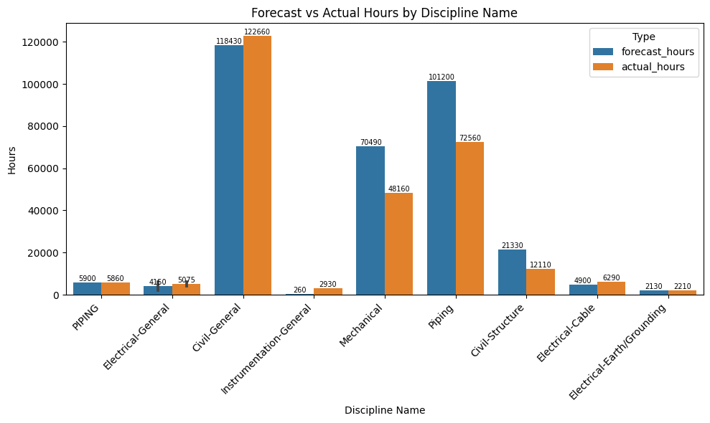

*Figure 1: Forecast vs. Actual Hours by Discipline. This graph illustrates the forecasted and actual hours for various disciplines, highlighting the discrepancies and efficiency gains.*

## Saved Manhours

The analysis showed that a significant percentage of manhours were saved across the projects. The percentage of saved manhours was calculated as follows:

*Percentage of Saved Manhours*

= (𝐹𝑜𝑟𝑒𝑐𝑎𝑠𝑡 ℎ𝑜𝑢𝑟𝑠−𝐴𝑐𝑡𝑢𝑎𝑙 ℎ𝑜𝑢𝑟𝑠) **/** 𝐹𝑜𝑟𝑒𝑐𝑎𝑠𝑡 ℎ𝑜𝑢𝑟𝑠×100 *= 15%*

This calculation indicates a **15%** reduction in the actual hours required compared to the forecasted hours, reflecting substantial efficiency improvements.

## Performance Efficiency

The overall performance efficiency across disciplines averaged 1.18, indicating an improvement in productivity. This metric shows that, on average, the actual hours spent on tasks were significantly less than the forecasted hours, underscoring the productivity benefits of using PACE OS.

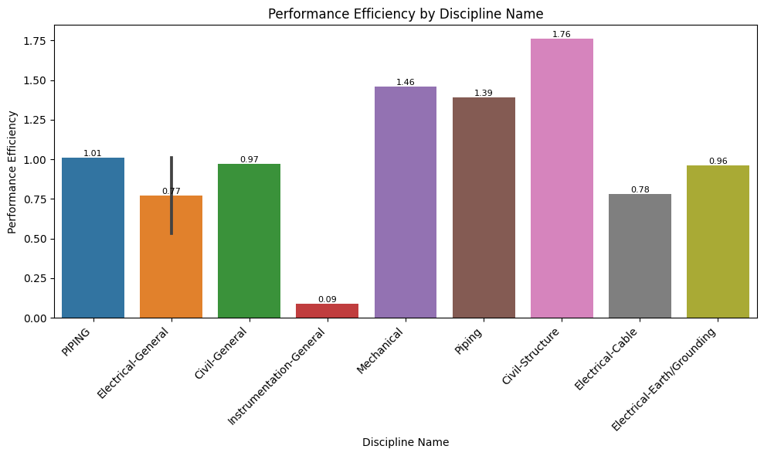  
*Figure 2: Performance Efficiency by Discipline. This chart presents the performance efficiency across different disciplines, showing the ratio of forecasted hours to actual hours, with an average efficiency of 1.18.*

## Monthly Progress Tracking

Regular tracking of planned, forecasted, and actual hours facilitated the identification of trends and allowed for timely adjustments to project plans. This proactive approach helped in maintaining project timelines and improving overall efficiency.

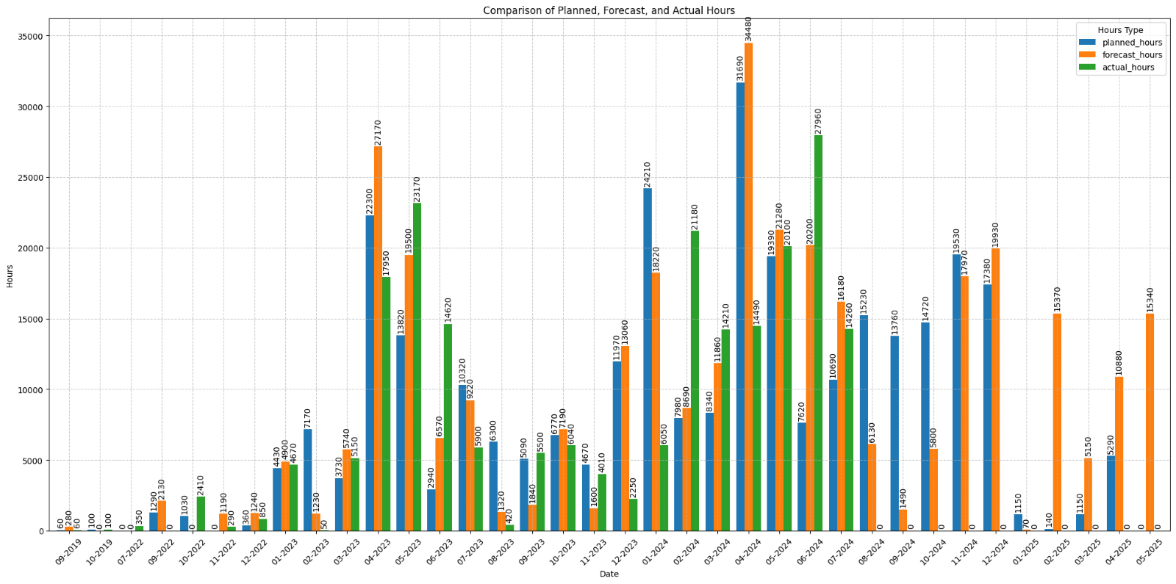  
*Figure 3: Comparison of Planned, Forecast, and Actual Hours. This timeline chart provides a detailed monthly comparison of planned, forecasted, and actual hours, illustrating the trends and progress of the projects.*

# Key Findings

## Productivity Gains

The implementation of CWPs and IWPs in PACE OS resulted in a 15% reduction in manhours, demonstrating significant productivity improvements. This reduction highlights the system's efficiency in optimizing work processes and minimizing unnecessary labor.

## Improved Project Scheduling

The integrated project schedules within PACE OS ensured better coordination and alignment across all sections of the project. This coordination minimized delays and bottlenecks, allowing for smoother workflow and timely completion of tasks.

## Data-Driven Decision Making

The availability of detailed performance metrics and real-time data enabled informed decision-making throughout the project lifecycle. This data-driven approach allowed project managers to continuously improve execution strategies, adapt to changing conditions, and maintain high standards of performance.

## Performance Efficiency

The overall performance efficiency across disciplines averaged **1.18**, indicating that for every hour of work forecasted, only approximately **0.85** hours were actually needed. This translates to an **18%** improvement in efficiency, reflecting the enhanced effectiveness of project execution facilitated by PACE OS. This significant efficiency gain demonstrates PACE OS's capability to deliver projects more quickly and with fewer resources than initially planned.

The implementation of PACE OS in managing CWPs and IWPs has significantly enhanced productivity, resource allocation, project scheduling, and decision-making in construction projects. These improvements underscore the value of advanced project management tools in driving efficiency and achieving better outcomes in the construction industry.

# Conclusion

The implementation of Construction Work Packages (CWPs) and Installation Work Packages (IWPs) within PACE OS has significantly elevated productivity levels and operational efficiencies in construction projects. This paper has detailed how PACE OS leverages these packages to streamline project management processes, achieving notable improvements in several key performance indicators.

Firstly, the integration of CWPs and IWPs has resulted in a remarkable 15% reduction in man-hours, showcasing a substantial boost in productivity. This improvement not only aligns with, but often surpasses industry benchmarks, which typically show lesser productivity gains from traditional project management systems ([Linarc](https://linarc.com/buildspace/construction-kpis/)).

Furthermore, PACE OS has enhanced resource utilization, ensuring that labor, materials, and equipment are allocated more efficiently. This efficiency is critical, as industry standards for resource utilization often highlight significant wastage in traditional construction processes ([FinModelsLab](https://finmodelslab.com/blogs/kpi-metrics/construction-project-management-kpi-metrics)).

In terms of cost and schedule compliance, PACE OS has demonstrated strong performance. Projects managed under this system have shown improved adherence to budgets and timelines, crucial metrics that are often challenging to maintain in the construction industry. This compliance with projected costs and schedules aligns with the best practices seen in high-performing construction projects worldwide.

Moreover, the system's impact on safety and quality standards has been profound. By providing more granular control and real-time data, PACE OS has helped project teams maintain stringent safety protocols and achieve higher quality outcomes, meeting or exceeding regulatory and industry standards.

In conclusion, the use of CWPs and IWPs within PACE OS represents a transformative advancement in construction project management. By breaking down complex projects into manageable tasks, enabling precise resource allocation, and enhancing performance monitoring, PACE OS not only improves project outcomes but also sets a new standard for the industry, pushing the boundaries of what is possible in construction management. This benchmark-setting performance positions PACE OS as an indispensable tool for firms aiming to achieve high efficiency, cost-effectiveness, and quality in their construction operations.

# References

1. McKinsey & Company. (2023). Insights on Construction Sector Productivity. [McKinsey & Company](https://www.mckinsey.com/capabilities/operations/our-insights/imagining-constructions-digital-future).
2. Propeller Analysis Tools. (2024). Construction Project Efficiency Report. [Propeller Tools](https://www.propelleraero.com/blog/10-construction-project-cost-overrun-statistics-you-need-to-hear/).
3. FinModelsLab. (2024). Resource Utilization in Construction: From Planning to Execution. [FinModelsLab](https://finmodelslab.com/blogs/kpi-metrics/construction-project-management-kpi-metrics).
4. Linarc. (2024). Project Management Solutions and Their Impact on Productivity in the Construction Industry. [Linarc](https://linarc.com/buildspace/construction-kpis/).